1/9/20.

H2 2001

Force = (mass) (acceleration)

His mass isn’t measuring up to what is humanly possible.

My theory: He’s not strong – he’s tuned in.

EMG Signal

Boost = chi (focused acceleration)

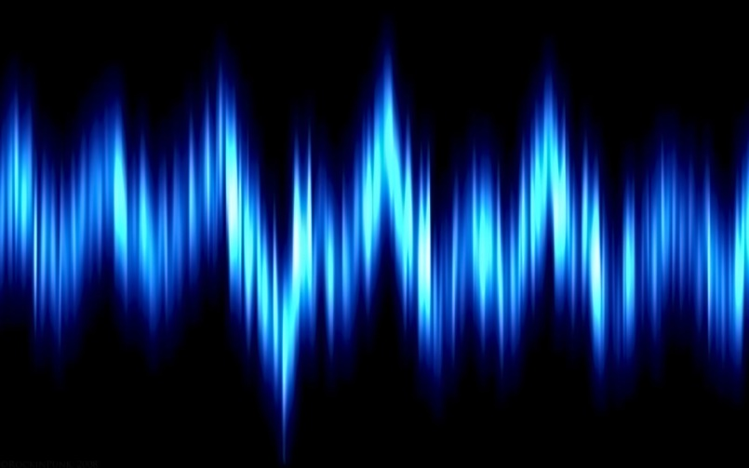

\* Also – Example: bending a wrench greater than 500 lbs of force.

1) initial force is focused onto a central point – then it moves to the next lb/ inch squared. (1 lb per sq. inch)